Data length, regression error, non-self match, k , anomal threshold, time

A – homothetic

B-DTW

1.**ECG 108**

a) (10000-11000), 3, 0.3,1,1.5,(870-951), 00:00:01

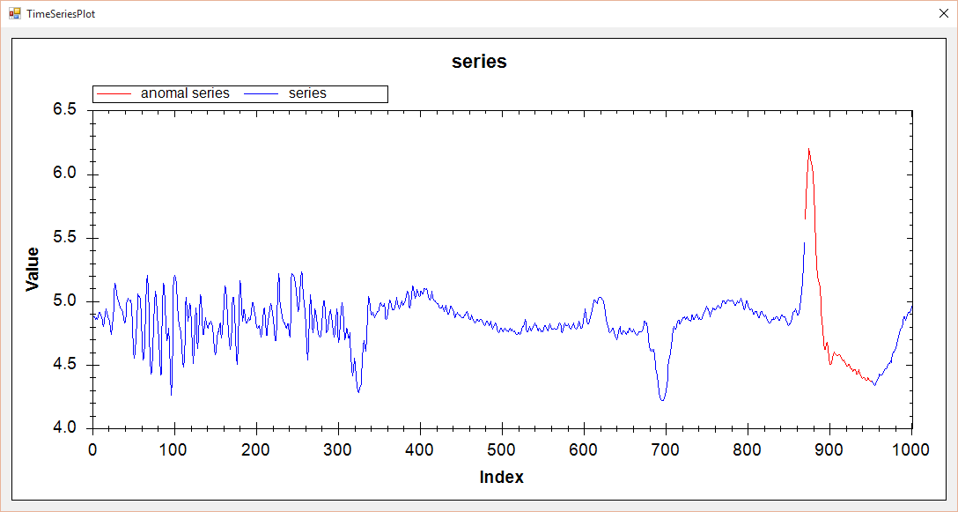

b) (10000-11000), 3, 0.3,1,3,(870-951), 00:00:14



**2. ECG_308**

a) (0-1299),30000,50,1,2,(682-698),00:00:01

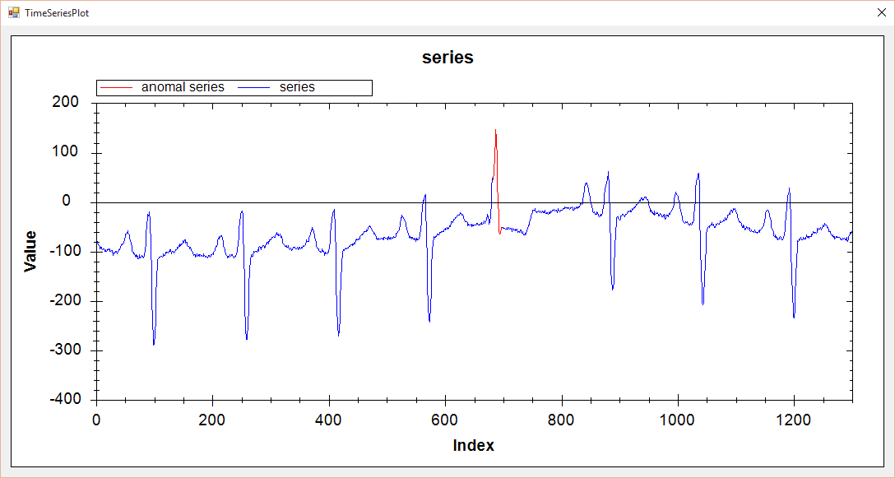

b) (0-1299),30000,50,1,3,(682-698),00:00:11



**3. ERP**

a) (2000-3000), 3.0, 1.0,1, 3.5,(643-686), 00:00:01

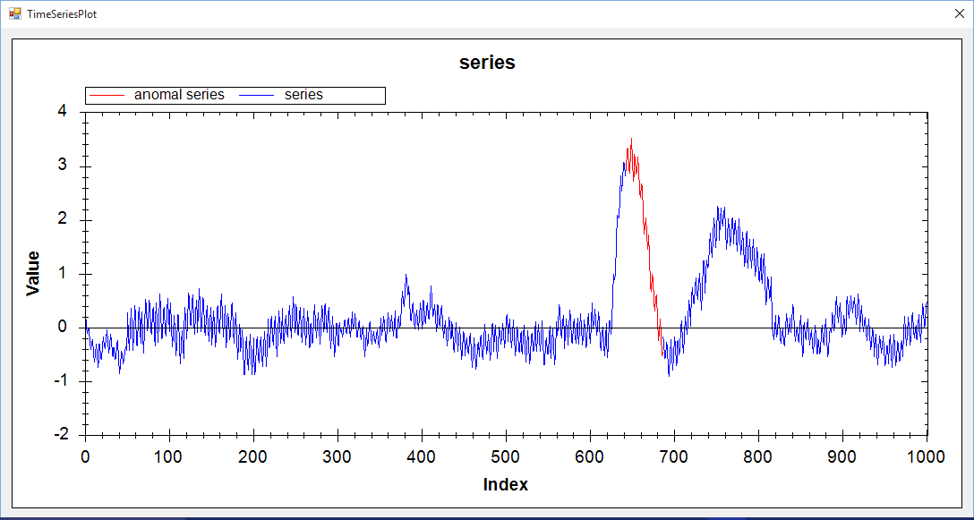

b) (2000-3000), 3.0, 1.0, 1, 3,(643-686), 00:00:05

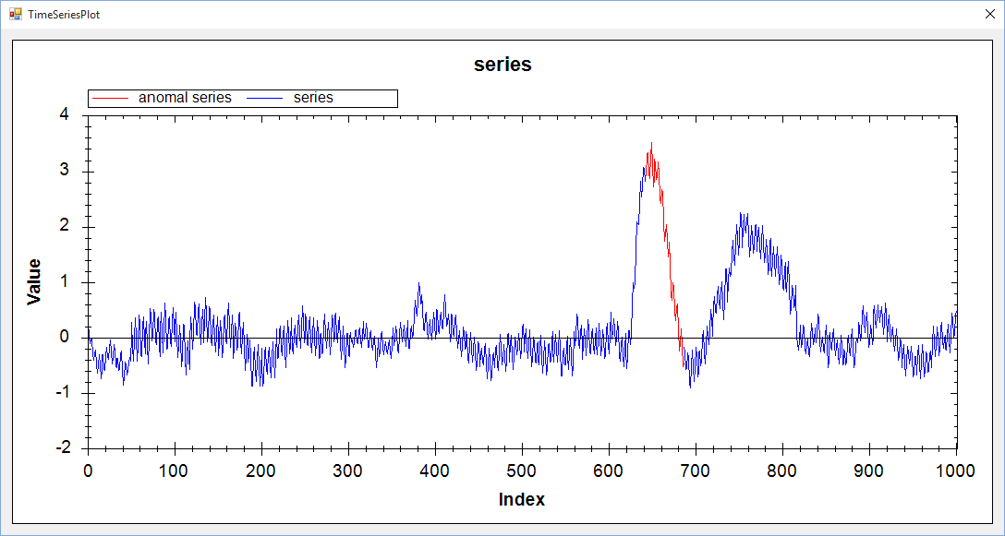

**4. Memory**

a) (2000-3000),8,0.1,1,1.5,(425-590),00:00:01

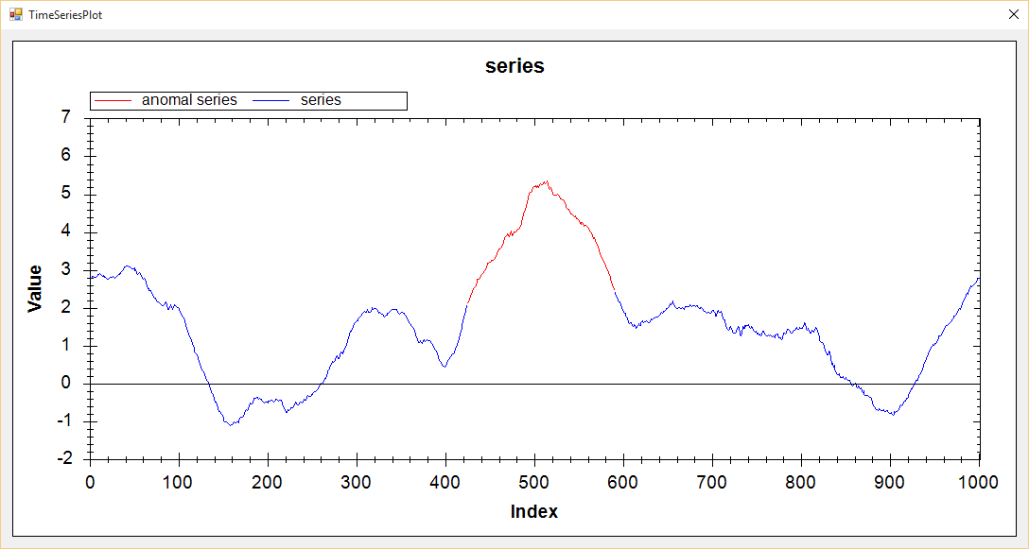

b) (2000-3000),9,0.1,1,2.5,(429-614),00:00:04

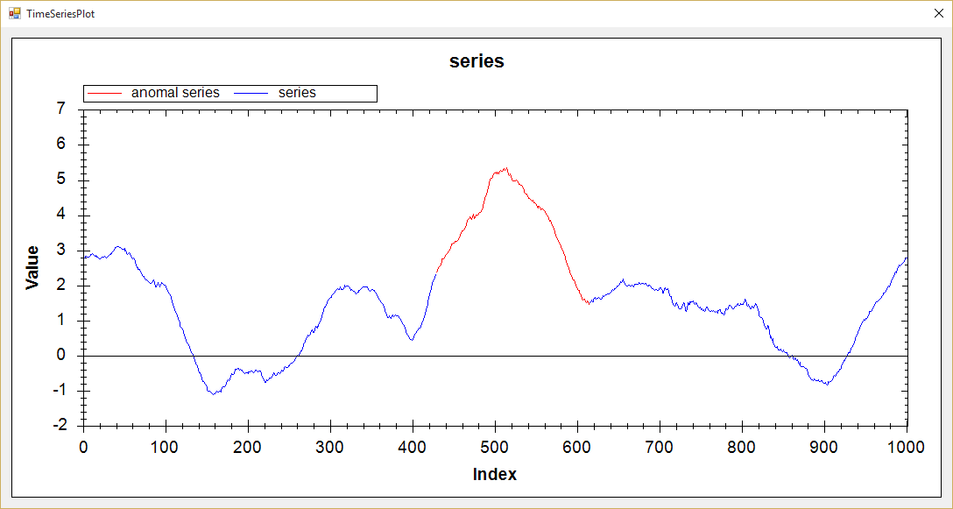

**5. Power_Dustch**